3.1 Issues in maintaining SBRs
Exercise
Answer the following questions about IVA calculation and ISIC classification
- A media business provides the following information about their operations in a year:

Activity | Staff headcount | Staff wages | Rental of office space | Other operating costs | Taxes paid | Profit
Producing and broadcasting a local TV news programme | 64 | € 2.8 million | € 2.4 million | € 1.2 million | € 0.2 million | € 0.8 million
Publishing a monthly magazine | 38 | € 1.8 million | € 1.2 million | € 0.4 million | € 60,000 | € 0.2 million
Producing a political podcast | 6 | € 0.3 million | € 45,000 | € 40,000 | € 75,000 | € 0.3 million

  - Using value added, what should be the 3-digit ISIC code for the business’s primary activity?

  - Using value added, what should be the 3-digit ISIC code for the business’s secondary activity?

  - If you only had access to turnover for the business, would its primary and secondary ISIC codes change?

- Using the EU definition of small and medium enterprises (reproduced below), what should be the size class for the media business in Question 1?
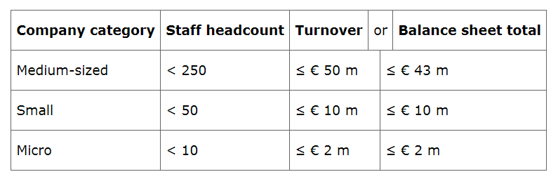

Annex: Relevant ISIC Rev. 4 codes

Division 58 Publishing activities
581 Publishing of books, periodicals and other publishing activities
5811 Book publishing
5812 Publishing of directories and mailing lists
5813 Publishing of newspapers, journals and periodicals
5819 Other publishing activities
582 5820 Software publishing

Division 59 Motion picture, video and television programme production, sound recording
and music publishing activities
This division includes production of theatrical and non-theatrical motion pictures whether on film, videotape or disc for direct projection in theatres or for broadcasting on television; supporting activities such as film editing, cutting, dubbing etc.; distribution of motion pictures and other film productions to other industries; as well as motion picture or other film productions projection. Also included is the buying and selling of distribution rights for motion pictures or other film productions. This division also includes the sound recording activities, i.e. production of original sound master recordings, releasing, promoting and distributing them, publishing of music as
well as sound recording service activities in a studio or elsewhere.

591 Motion picture, video and television programme activities
5911 Motion picture, video and television programme production activities
5912 Motion picture, video and television programme post-production activities
5913 Motion picture, video and television programme distribution activities
5914 Motion picture projection activities
592 5920 Sound recording and music publishing activitiesDiv
ision Group Classscr

iption
Division 60 Programming and broadcasting activities
This division includes the activities of creating content or acquiring the right to distribute content and subsequently broadcasting that content, such as radio, television and data programs of entertainment, news, talk, and the like. Also included is data broadcasting, typically integrated with radio or TV broadcasting. The broadcasting can be performed using different technologies, over-the-air, via satellite, via a cable network or via Internet. This division also includes the production of programs that are typically narrowcast in nature (limited format, such as news, sports, education or youth-oriented programming) on a subscription or fee basis, to a third party, for subsequent broadcasting to the public. This division excludes the distribution of cable and other subscription programming (see division 61).

601 6010 Radio broadcasting
602 6020 Television programming and broadcasting activities

Division: 61 - Telecommunications
This division includes the activities of providing telecommunications and related service activities, i.e. transmitting voice, data, text, sound and video. The transmission facilities that carry out these activities may be based on a single technology or a combination of technologies. The commonality of activities classified in this division is the transmission of content, without being involved in its creation. The breakdown in this division is based on the type of infrastructure operated.
In the case of transmission of television signals this may include the bundling of complete programming channels (produced in division 60) in to programme packages for distribution.
611 6110 Wired telecommunications activities
612 6120 Wireless telecommunications activities
613 6130 Satellite telecommunications activities
619 6190 Other telecommunications activities

Division 63 Information service activities
This division includes the activities of web search portals, data processing and hosting activities, as well as other activities that primarily supply information.

631 Data processing, hosting and related activities; web portals
6311 Data processing, hosting and related activities
6312 Web portals
639 Other information service activities
6391 News agency activities
6399 Other information service activities n.e.c.

